# Tutorial : Strategic Asset Allocation

This document is set as follows: a brief introduction to the notion of asset allocation, the description of the Markowitz Model for the construction of the optimal risky portfolio and the calculations associated. Finally, an exercise will help to demonstrate how the Markowitz Model works.

In order to fully understand this tutorial, the reader should make sure that he understands the tutorial: [Asset DIversification](../Asset%20Diversification/Documents/Tutorial%20-%20Asset%20DIversification.docx)

## Asset Allocation

**Asset Allocation**

Asset allocation is an investment strategy that consists in dividing an investment portfolio among different asset categories such as stocks, bonds and cash.

This strategy relies mainly on two parameters: the investor’s time horizon and risk tolerance.

Time Horizon: the length of time over which an investor makes an investment in order to achieve a defined financial goal. The time horizon can vary from seconds to decades and depends on the investor’s objective.

Risk Tolerance: the ability or willingness of an investor to accept the potential loss of a given amount of his initial investment in the hopes the investment will increase in value.

For example an investor with a long time horizon and a high risk tolerance will be likely to allocate a large percent of his total portfolio to higher-risk securities such as stocks. A contrario, an investor with a shorter time horizon and a low risk tolerance will mainly invest in safer securities like bonds and cash.

[Guide to Asset Allocation](Guide%20to%20Asset%20Allocation.docx)

## The optimal risky portfolio

When creating a risky portfolio, an investor should always keep in mind that he has to split his money between risky (stocks + bonds) and riskless (cash) assets in order to properly manage the overall risk and return of his portfolio.

The investor has to know first the composition of the risky part of his portfolio (stocks + bonds) in order to choose how much he is willing to invest in it. The remaining part of his investment will be then placed in riskless assets (cash) in order to balance the global risk. The proportion of risky assets vs riskless assets in the portfolio depends on the risk profile of the investor.

Now we will see how to calculate the composition of the optimal risky portfolio (portfolio of all the risky assets).

**The Sharpe Ratio**

In order to compute the optimal risky portfolio we need to use the Sharpe ratio.

This ratio measures the excess of return of an investment per unit of risk taken. The excess return of an investment is just the amount of money you will earn with this risky investment compared to amount of money you could earn from the riskless investment.

The Sharpe ratio has the following formula:

$$S=\frac{(E\left(r_{P}\right)-R_{f})}{σ_{P}}$$

Where:

* $E\left(r_{P}\right)$ is the expected return of the investment,
* $σ_{P}$ is the standard deviation of the investment
* $R_{f}$ is the risk free rate

Example:

Leo has invested in a portfolio P with and expected return of 14% and a global risk of 7%. The risk free rate is 5%, calculate the Sharpe ratio of Leo’s portfolio.

$$S=\frac{14-5}{7}=1.28$$

Now Lea has invested in a portfolio with an expected return of 8% and a risk of 2%. According to the Sharpe ratio which one is the best portfolio?

Lea’s investment has the following Sharpe Ratio:

$$S=\frac{8-5}{2}=1.5$$

Lea’s Sharpe ration is bigger than Leo’s so for each unit of risk taken she earns more than Leo. We can conclude that Lea’s portfolio is better than Leo’s.

**The Optimal Risky portfolio**

To calculate the composition of the Optimal Risky Portfolio, we simply compute the weight of each risky asset so they maximize the Sharpe Ratio.

For the case of a 2 assets risky portfolio:

|  |  |  |  |
| --- | --- | --- | --- |
| Assets | Asset1 | Asset2 | Risk Free Rate |
| Expected Return | $$E(r_{1})$$ | $$E(r_{1})$$ | $$R_{f}$$ |
| Risk | $$σ_{1}$$ | $$σ_{2}$$ | 0 |
| weight | $$w_{1}$$ | $$w_{2}$$ | 0 |

$$Max(S)=\frac{(E\left(r_{P}\right)-R_{f})}{σ_{P}}$$

Where :

* $σ_{P}$ is the global risk of the portfolio
* $E\left(r_{P}\right)$ is the expected return of the portfolio
* $R_{f}$ is the risk free rate

By replacing $E\left(r_{P}\right)$, $σ_{P}$ by their formulas and $w_{2}$ by 1- $w_{1}$

We can derivate the expression with respect to $w_{1}$ and set that derivative equal to 0.

After a lot of calculation we find:

$$w_{1}=\frac{\left(E\left(r_{1}\right)-R_{f}\right)*σ_{2}^{2}- \left(E\left(r_{2}\right)-R_{f}\right)*Cov(r_{1},r_{2})}{\left(E\left(r_{1}\right)-R_{f}\right)*σ_{2}^{2}+\left(E\left(r_{2}\right)-R_{f}\right)*σ_{1}^{2}-\left[\left(E\left(r_{1}\right)-R_{f}\right)+\left(E\left(r_{2}\right)-R_{f}\right)\right]*Cov(r_{1},r_{2})}$$

$$w_{2}=1-w_{1}$$

Example:

Let’s consider the two following assets:

|  |  |  |
| --- | --- | --- |
| Assets | Asset1 | Asset2 |
| Expected Return | 12% | 20% |
| Risk | 4% | 10% |

The correlation coefficient of these two assets is : Rho = 0.16.

The risk free rate is 5%.

We can then compute the optimal portfolio of the two assets:

$$w_{1}=\frac{\left(12-5\right)*{10}^{2}-\left(20-5\right)*0.16*4*10}{\left(12-5\right)*{10}^{2}+\left(20-5\right)*4^{2}-\left[12-5+20-5\right]*0.16*4*10}=\frac{591.2}{799.2}=73.9\%$$

$$w_{2}=1- w_{1}=26.1\%$$

We can then deduct that the optimal portfolio’s risk and expected return are respectively 4.2% and 14.1%.

Finally we can locate the optimal portfolio on the efficient frontier:

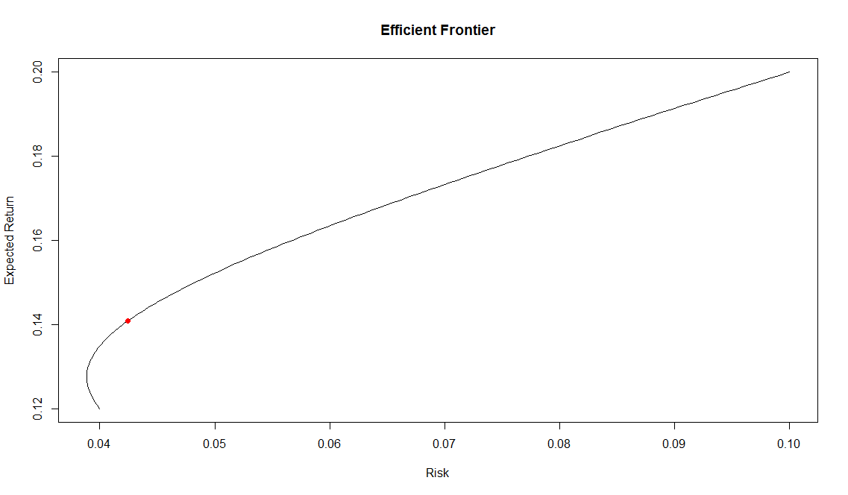

What’s interesting with the asset allocation is that the composition of the risky portfolio (optimal portfolio) will be the same for every investor. Only its proportion in the complete portfolio (risky portfolio + riskless asset) will change to fit the investor’s risk profile.

For the case of a 3 or more assets risky portfolio:

This case is way more complicated than the previous one so we won’t develop it here. If you are interested in understanding how to solve the optimisation problem using Matrix Algebra and R, please refer to the following document:

<portfolioTheoryMatrix.pdf>

**Capital Allocation Line (CAL)**

The CAL is the line that represents all the possible combinations of the risky portfolio and the riskless asset. In the end this line represents all the possible complete portfolio that an investor can create.

The Equation for this line is the following:

$$E\left(r_{c}\right)=\frac{(E\left(r_{P}\right)-R_{f})}{σ_{P}}*σ_{c}+R_{f}$$

Where:

* $E\left(r_{c}\right)$ and $E\left(r_{P}\right)$ are respectively the expected returns of the complete portfolio and the risky portfolio.
* $σ_{c}$ and $σ_{P}$ are respectively the risks of the complete portfolio and the risky portfolio.
* $R_{f}$ is the risk free rate

Example:

Let’s use the optimal portfolio computed in the previous example.

In this case we can calculate the equation for the CAL:

$$E\left(r_{c}\right)= \frac{14.1-5}{4.2}*σ_{c}+5$$

We can plot this line:

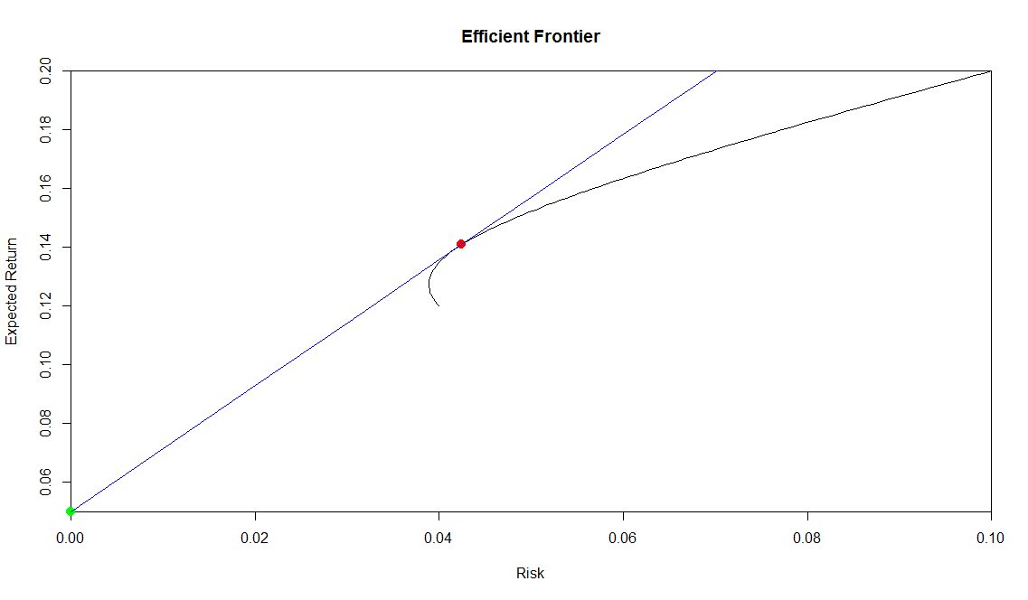

So as you can see, the CAL is the blue line. The green and red points represent respectively the risk free rate and the optimal risky portfolio. All the complete portfolios formed by investing in the risk free rate (lending money at the risk free rate) and the optimal portfolio lie on the CAL between the green and the red points. However we can also observe that if the investor has the possibility to borrow money at the risk free rate (leverage) he can create all the complete portfolios located on the CAL above the red dot. These last portfolios, as we can see have for the same amount of risk a better expected return than the ones lying on the efficient frontier.

**Calculating the Risk and Expected Return of the complete portfolio**

Once the proportion of risky vs risk free assets has been determined for the complete portfolio, calculating its Risk and Expected return is like calculating the risk and return of a portfolio of two assets.

Example:

Let’s consider an investor who wants to create a portfolio with 3 stocks and cash.

The optimal portfolio of the 3 stocks has an expected return of 29% and a global risk of 10.5%, the riskfree rate for lending cash is 1% and finally the investor is willing to lend 25% of his money at the riskfree rate.

Let’s calculate the complete portfolio’s risk and expected return:

Risk:

$$σ_{c}=\sqrt{(0.75*0.105)²}=0.75*0.105=0.0787=7.9\%$$

We use the same formula as for calculating the risk of a 2 assets portfolio, but as the riskfree asset has a risk equals to 0 we obtain the previous result.

Expected Return:

$$E\left(r_{c}\right)=0.75*0.29+0.25*0.01=0.22=22\%$$